Order Of Service

Singing: Psalm 85—CW page 97

Reading: Psalm 86

Opening Hymn: CW 260

Reading: Acts 14:24-28

Request Hymn: CW Supplement 735

Reading: Matthew 4:12-17

Sermon Hymn: CW 496

Sermon Text: Mark 1:35-39

Moving On

Prayer

The Apostles’ Creed, TLH page 12

Holy Communion

The Lord's Prayer

The Blessing

Closing Hymn: CW 449

* * * * * * * * * * *

Koinonia Hour



Autumn In Minnesota

Water
Of
Life

4 November 2018

W A T E R O F L I F E

Independent Christian Church—Conservative Lutheran Doctrine

Worship Service: 9:30 a.m. Bible Study: 10:45 a.m.

Larry Cooper, Pastor E-Mail address:
111 N. Ridge Road lcooper@wateroflife.cc
Coon Valley, WI 54623 Web Site:
Phone: (608) 452-2105 www.wateroflife.cc

* * * * * * * * * * * * * * * * * * * * * * * * * * *

Sermon Text: Mark 1:35-39

Moving On

* * * * * * * * * * * * * * * * * * * * * * * * * * *

Mark 1:35 And in the morning, rising up a great while before day, he went out, and departed into a solitary place, and there prayed.
:36 And Simon and they that were with him followed after him.
:37 And when they had found him, they said unto him, All men seek for thee.
:38 And he said unto them, Let us go into the next towns, that I may preach there also: for therefore came I forth.
:39 And he preached in their synagogues throughout all Galilee, and cast out devils.

Multitudes Seeking Jesus

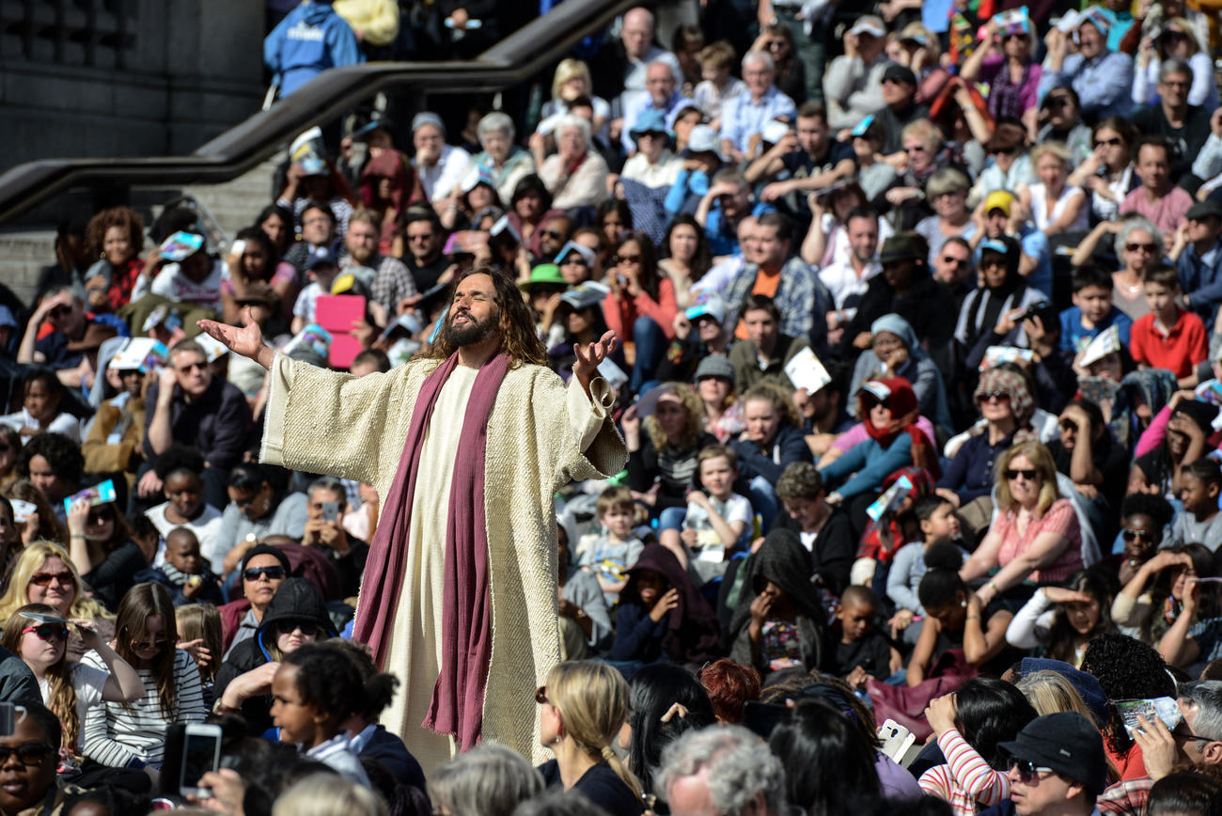

Jesus Praying In Solitary Place

